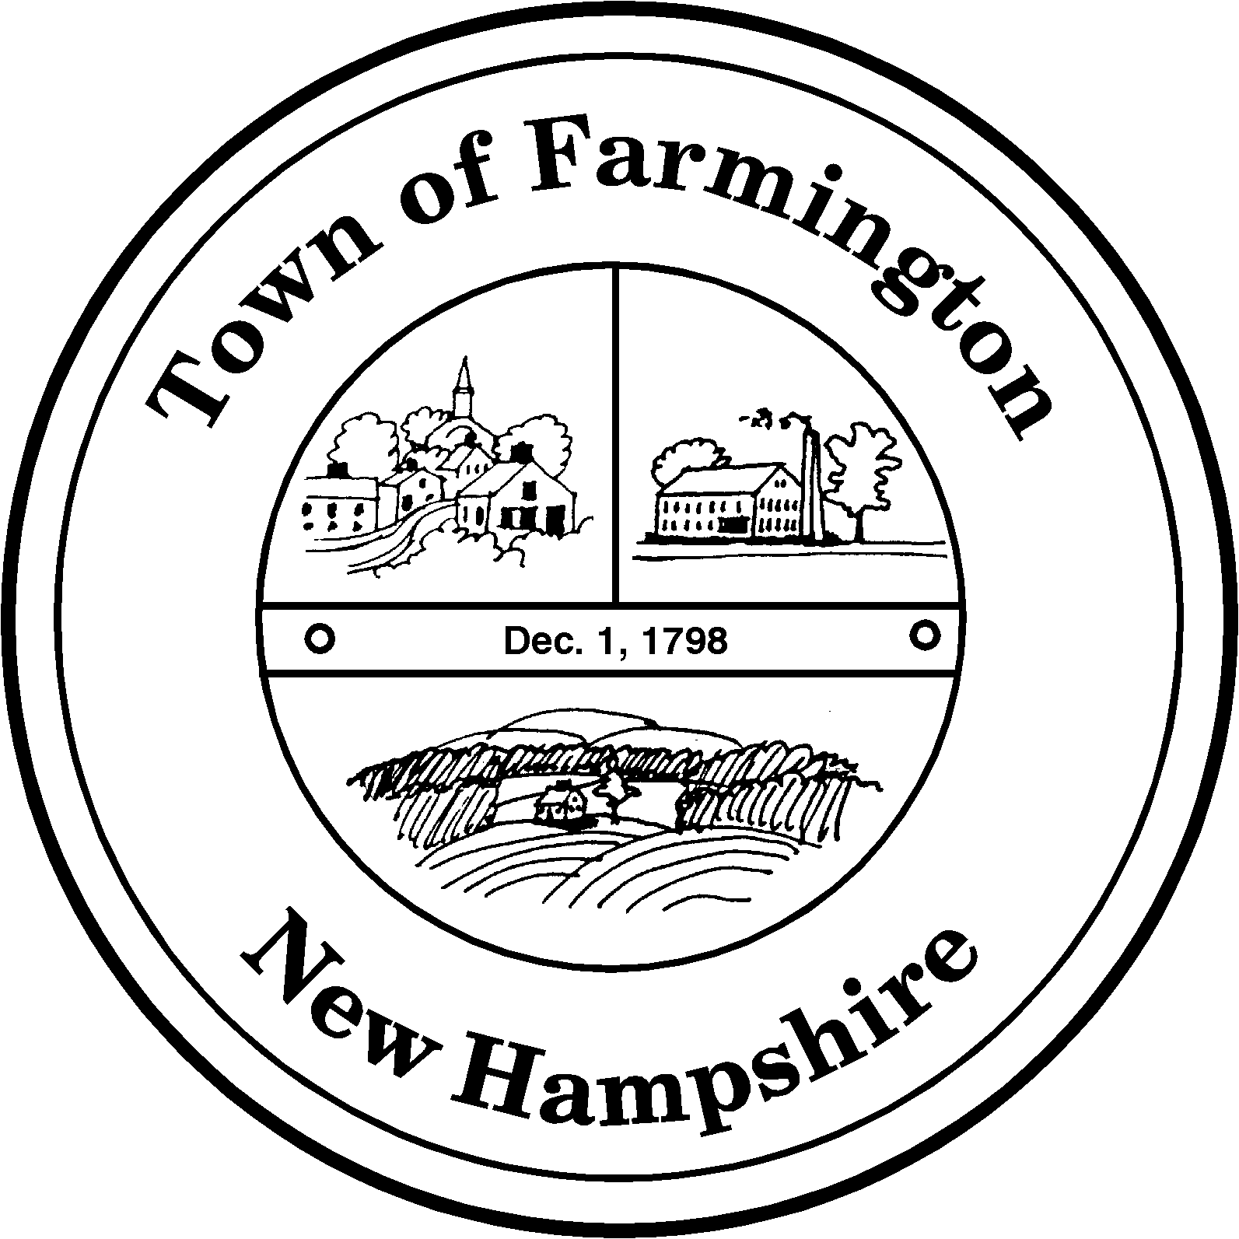
Town of Farmington
Planning and Community Development
356 Main Street
Farmington, NH 03835
Phone: (603) 755-2774
A Bicentennial Community
1798 - 1998

PLANNING BOARD MEETING

Tuesday – March 7, 2017

356 Main Street - Farmington, NH

AGENDA - 6:00 pm

BUSINESS BEFORE THE BOARD:

- Pledge of Allegiance
- Review and approve Meeting Minutes of February 21, 2017
- Voluntary Lot Merger Application submitted by Jesse and Jennifer MacIsaac for Tax Map R06 Lot 11 and R06 Lot 110 located at 326 Camelot Shore Drive. The new lot number will be R06 Lot 110.
- Review of draft guidance on application procedures

PUBLIC HEARING - 6:30 pm

New Cases:

Charles Doke, Chairman

Farmington Planning Board

